AMA Access Tahla
23-03-2014
Portfolio
Orientation and placement test.
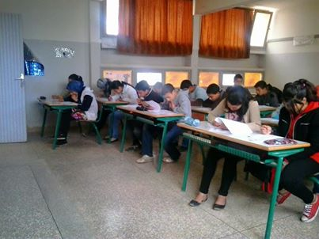

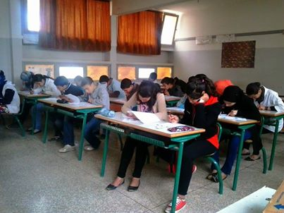

The orientation session was meant to make students comfortable and to get them to know each other and get familiar with their teachers. Students play “What’s Everyone’s Name” game. They stand in a circle and introduce themselves. The next person then repeats all the names of the students in front of him, going around the circle until everyone has said their names and everyone else’s names. If someone gets a name wrong after the initial introduction round, he/she is out.
Placement Test:
Students work individually on their placement tests.

